Spark 3.4.3 Single-Node Cluster Installation
on Ubuntu 22.04 on Docker

Create and run a new container from an image
Execute the following in Windows’ Command Prompt:
cd spark-cluster

docker run -p 9870:9870 -p 7070:7070 -p 8080:8080 ^
--name spark-standalone --hostname spark ^
--mount type=bind,source=.,target=/share ^
-it trungphansg/hadoop1:1.0.2
Note: The software installed on the virtual machine includes: Ubuntu 22.04, Java 8, Hadoop 3.4.0, HBase 2.4.17, Hive 3.1.2

Install Spark

Install Scala
Since Spark is written in Scala, Scala must be installed to run Spark applications:
sudo apt install scala
scala -version

Install Spark
Download Spark:
wget https://archive.apache.org/dist/spark/spark-3.4.3/spark-3.4.3-bin-hadoop3.tgz
Note: To save time, you can copy the installation file to the virtual machine as follows:
docker cp spark-3.4.3-bin-hadoop3.tgz spark-standalone:/
Decompress and move Spark into the /usr/local/spark folder:
tar xvzf spark-3.4.3-bin-hadoop3.tgz
sudo mv spark-3.4.3-bin-hadoop3 /usr/local/spark
[rm spark-3.4.3-bin-hadoop3.tgz]

Config Spark
cd
nano .bashrc
Append the following lines:
# Spark
export SPARK_HOME=/usr/local/spark
export PATH=$PATH:$SPARK_HOME/bin:$SPARK_HOME/sbin
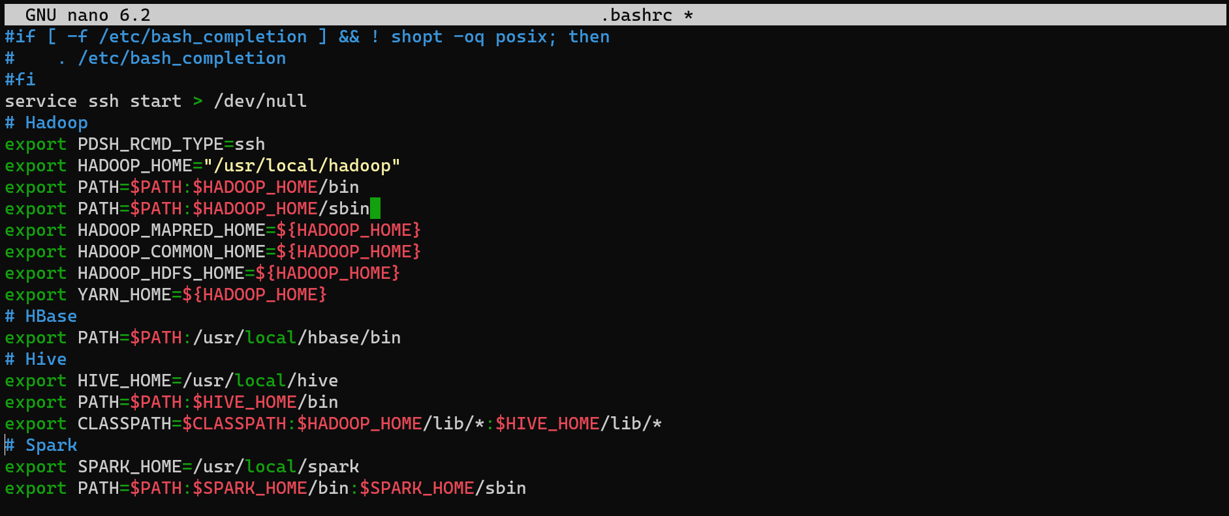
Save file and exit from nano: Ctrl-S, Ctrl-X.
Load the .bashrc file:
source .bashrc

Basic operations on Spark

Run Spark Shell
Spark Shell provides an interface to perform basic operations on Apache Spark. This interface is very convenient when experimenting and researching. To run Spark Shell we use the following command:
spark-shell
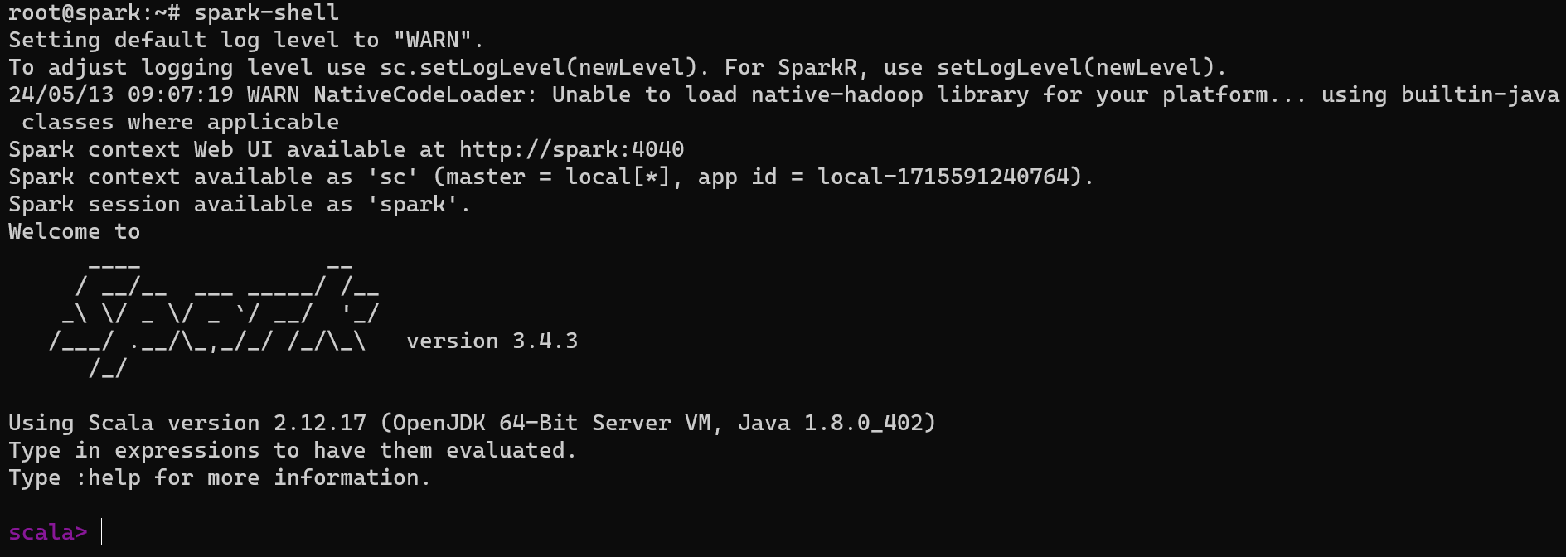

Exit from Spark Shell
:q or :quit

Create a new image from the container
Exit from the container, stop the container and execute the following command in Windows’ Command Prompt:
docker commit spark-standalone spark:standalone
Check the result:
docker images
When you need to recreate the container from this image, use the following command:
docker run -p 9870:9870 -p 7070:7070 -p 8080:8080 ^
--name spark-standalone --hostname spark ^
--mount type=bind,source=.,target=/share ^
-it spark:standalone

